Register Number: _____________________

DHANALAKSHMI SRINIVASAN ENGINEERING COLLEGE, PERAMBALUR – 621 212
(AUTONOMOUS)
DEPARTMENT OF AERONAUTICAL ENGINEERING
U20AE502/ Aircraft Structures Mechanics
MODEL TEST – I
Year /Semester: III / V Date:
Duration: 3 hours Total Marks: 100

Part A: 10 X 2 = 20 Marks
Answer all the questions
1 | Define unsymmetric bending. | 2 | CO1 | BTL2
2 | Define shear flow. | 2 | CO1 | BTL1
3 | Define shear center. | 2 | CO2 | BTL2
4 | Define principal axis . | 2 | CO2 | BTL2
5 | What is effective width? | 2 | CO3 | BTL1
6 | List down structural components of in an aircraft wing. | 2 | CO3 | BTL2
7 | List down structural components of in the fuselage. | 2 | CO4 | BTL2
8 | What is semi tension field beam? | 2 | CO4 | BTL1
9 | Differentiate between monocoque and semi-monocoque structures. | 2 | CO5 | BTL2
10 | Write the formula for Bredt-Batho equation. | 2 | CO5 | BTL2

Part B: 5 X 16=100
Answer all the questions
11 | a | i | Find the bending stress at corner points of Z-section shown in fig.1 with flanges 10×3 cm & web 15×3 cm subjected to moments Mx =10kN-m & My =5kN-m also calculate the neutral axis  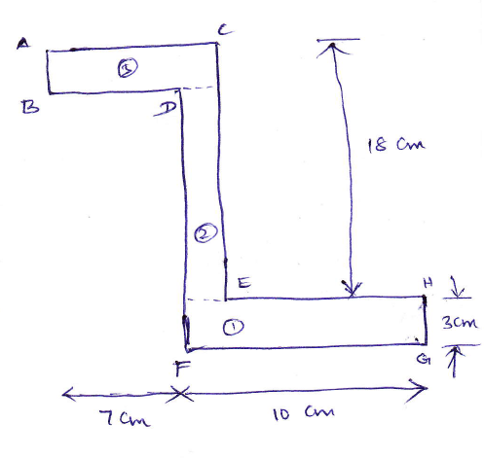 | 16 | CO1 | BTL3
11 | Or
11 | b | ii | Find the normal stress distribution of a thin-walled Z-section, thickness t, height of the web h, and flange width h/2, when it's subjected to a bending moment Mx.  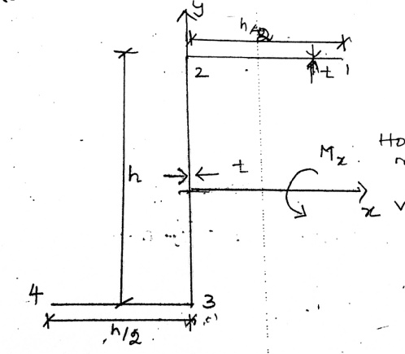 | 16 | CO1 | BTL3
12 | a | i | The section shown in fig.2 is subjected to vertical shear of 60 kN applied through shear center. Obtain the shear flow for the section. Area of all the stringers are same and equal to 7 cm². | 16 | CO2 | BTL3
12 | Or
12 | b | ii | Find the shear flow for open section Shown in fig i) Find the line of action of the force so that the section doesnot rotate ii) Find the shear center of the section.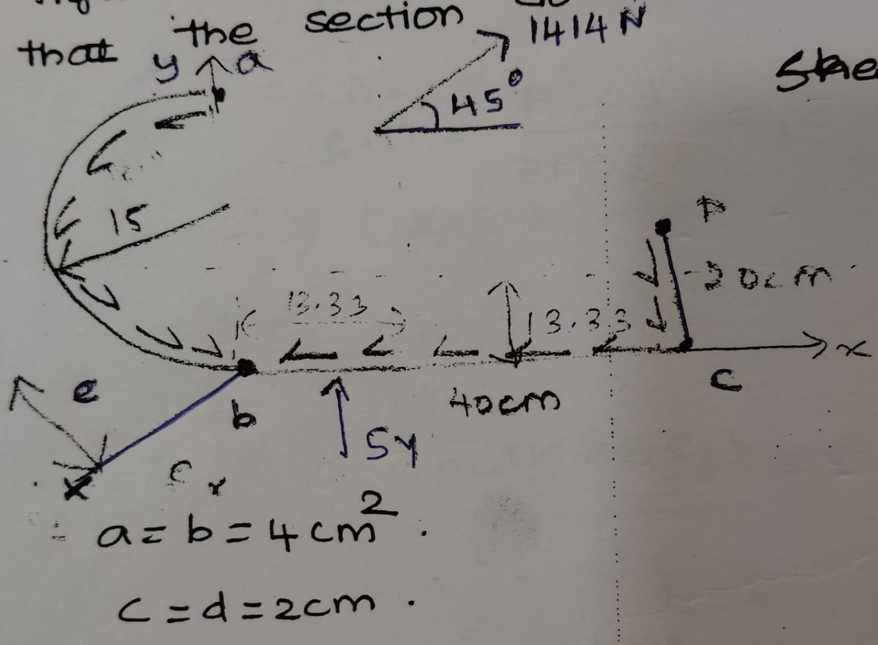 | 16 | CO2 | BTL3
13 | a | i | Find the shear and angle twist for given for multicell.  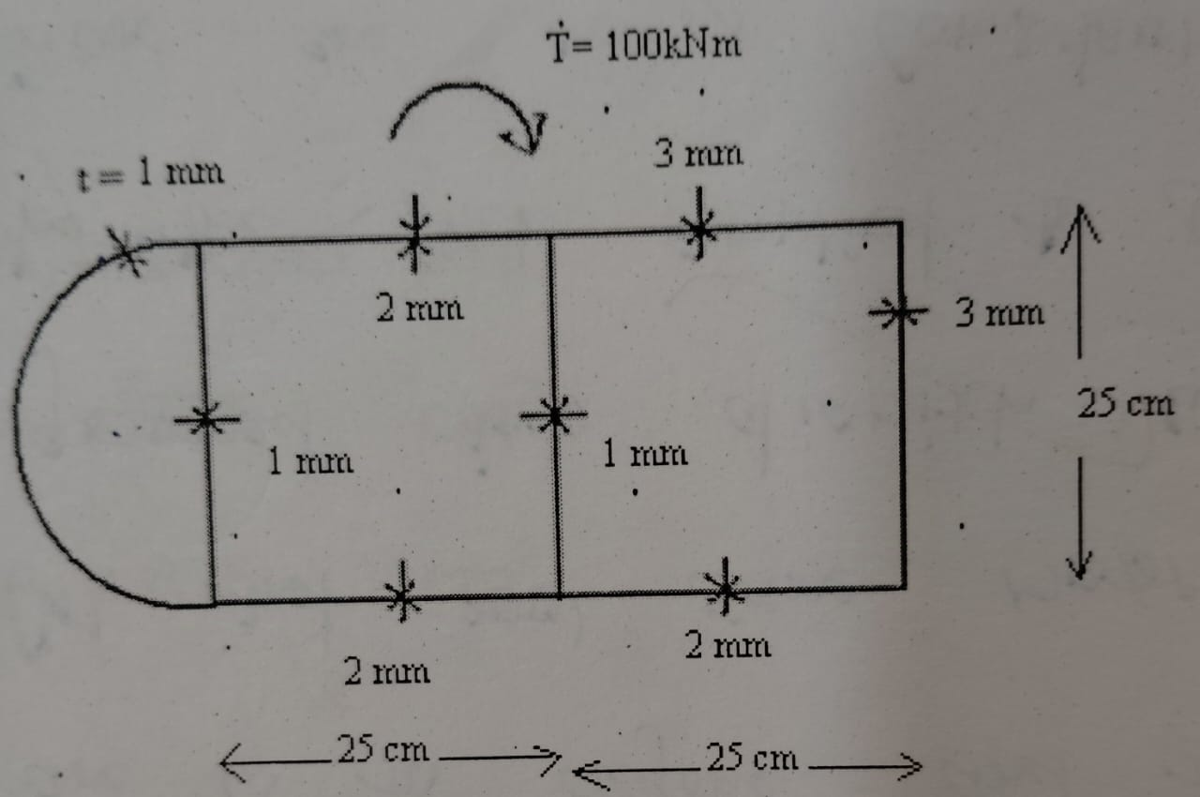 | 16 | CO3 | BTL3
13 | Or
13 | b | ii | A multicell structure shown in fig. subjected to clockwise torque of 1000 N-m. Compute a shear flow in a cell structure and the associated twist. The structure has constant thickness of 3 mm.  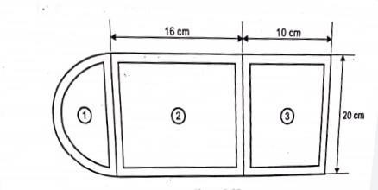 | 16 | CO3 | BTL3
14 | a | i | The sheet stiffened panel consisting of 3 stringers of 25cm long located with 10cm spacing and sheet of 30cm×25cm×1mm as shown in fig is loaded in compression by means of rigid members. The sheet is assumed to be simply supported at loaded ends and at a rivet lines and to be free at the sides. Each stringers has an area of 50mm2. Assume E = 72.5 GPa for sheet and stringers. Find the total compressive P, (i) whenthe sheet first buckles, (ii) when the stringer stress is 70 MPa, (iii) when the stringer stress is 210 MPa.  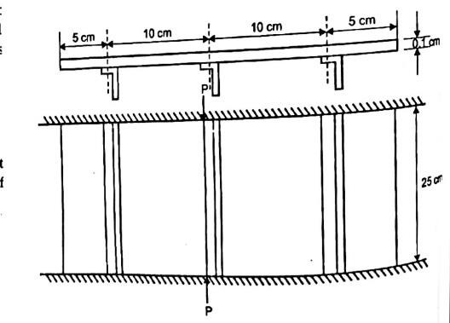 | 16 | CO4 | BTL3
14 | Or
14 | b | i | Explain and derive Bredt-Batho formula with its assumptions? | 16 | CO4 | BTL3
15 | a | i | The idealized single cell thin walled tube is shown in fig has a horizontal axis of symmetry. Direct stresses are carried by the booms B1 to B8 ; while the walls are effective only in carying shear stress. Calculate the distribution of shear flow around the section. Given B1=B8=2cm² ; B2=B7=2.5cm² B3=B6=4 cm² ; B4=B5=1 cm² . | 16 | CO5 | BTL3
15 | Or
15 | b | i | A fuselage bulkhead of 1m diameter has a stringers equally placed around the section starting from top point. Each stringer area is 6.25cm². The bulk head is subjected to a symmetrical vertical shear load of 10KN. Find the shear flow around the bulk head? | 16 | CO5 | BTL3

Prepared by Verified by

